**Faculty Proforma for the GMC Budan Website**

1. Name: DR. Lalendra Yadav

..........................

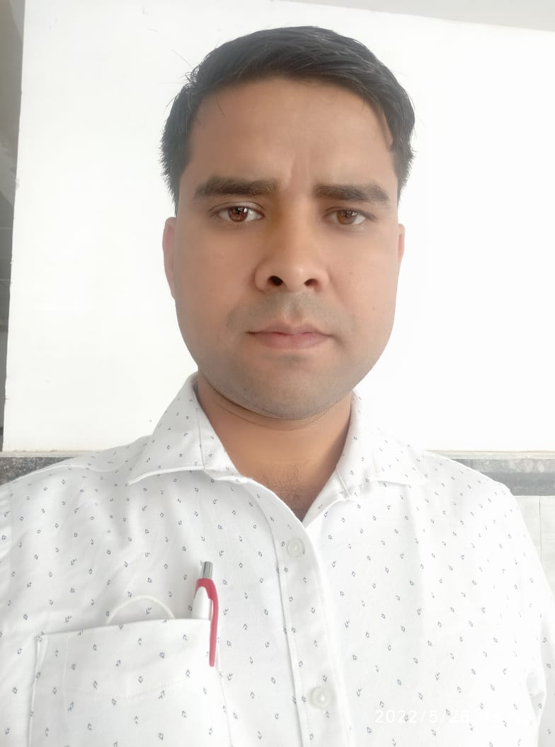

2. Qualification: M.Sc., Medical Pharmacology

3. Fellowships:

4. Date of joining: 12.04.2022

5. Date of Birth: 17.02.1988. Gender: Male

6. Designation: Assistant Professor

7. Department: Pharmacology

8. Specialization: Medical Pharmacology

9. Area of Interest: Teaching & Research

10. OPD days:.......................NA..............................................................................................................

11. OPD RoomNo.: ......................N A .........................Timings:....N A............

12. Super speciality clinic: ....NA....Room No / wardNo. : ......NA..........

13. Super speciality clinicdays.....................NA..........................Timings:...............NA..................

14. Awards:.......................................................................................................................................

a.International

b.National

c.Statelevel

d.DistrictLevel

15.Achievements:

a. Publications (Index/Peer reviewed):.............

|  |  |  |  |
| --- | --- | --- | --- |
| **Sl.**  **No.** | **Title of Article** | **Journal** | **Year/Month** |
| 1 | Matreja PS, Kaur J, **Yadav L**. Acceptability of  the use of crossword puzzles as an assessment methods in pharmacology. | J Adv Med Educ Prof. | july 2021 |
| 2 | Mahat RK, Panda S, Rathore V, Swain S, **Yadav L**,  Sah S. The dynamics of inflammatory  markers in coronavirus  disease-2019 (COVID-19) patients: A systematic review  and meta-analysis. | Clinical  Epidemiology and Global Health | 2021 (Elsevier) |
| 3 | Lata S, Yadav AK, Sharma RK, Jindal M, Suman A, **Yadav** **L**, Malik P. Cost effective Auditing  of prescriptions of Indoor Patients in a tertiary care Teaching Hospital: A Retrospective Study. | J Rational  Pharmacother  Res, | 2018 |
| 4 | Sah SP, Arora M, Kumar S, Batra J, Mustafa I, **Yadav L**. Effect of PEM on thyroid status, serum total protein and A/G ratio in pre-school going children. | Int J Res Med  Sci, | 2017 October |
| 5 | Yadav SK, Kumar S, Tak V, Kushwaha DKS, **Yadav L**, Yadav J. Prevalence of Urinary Tract Infection among Diabetic Patients in North India. | Ann. Int.  Med. Den. Res. | 2015. |
| 6 | Kushawaha DKS, Farooq U, Begum R, Tak V, **Yadav L**, Yadav SK, Yadav J. Environmental Surveillance of Filamentous Fungi in Hospital Air Sampling. | Journal of Microbiology, Immunology and Biotechnology. | 2015 |
| 7 | Vishwakarma K, Khan FA, Nizamuddin S, Singh P, **Yadav L**. Role of Topical Acetic Acid in Comparison to Gentamicin for the Management of Chronic Suppurative Otitis Media. | Int Arch  BioMed Clin  Res. | 2015 Aug. |
| 8 | **Yadav L**, Singh H, Chandra H. A Comparative Study to Evaluate the Effectiveness and Efficacy of Topical Application of 1.5% Acetic Acid and 0.3% Gentamicin Sulfate in CSOM Patients of Tertiary Care Teaching Hospital of North India. | Journal of  Dental and Medical Sciences | 2015 |
| 9 | * Giri VP, Giri OP, Kanodia S, **Yadav L**, Gupta SK. Prescription Pattern in Atopic Dermatitis in Outpatients in a Tertiary Care Teaching Hospital at Darbhanga, Bihar, India. | Int J Sci Stud | 2014 |

b. Publications (Nonindexed):............................................................................

|  |  |  |  |
| --- | --- | --- | --- |
| **Sl.**  **No.** | **Title of Article** | **Journal** | **Year/Month** |
|  |  |  |  |

c. Books/Book Chapters:...................................................................................

|  |  |  |  |  |  |
| --- | --- | --- | --- | --- | --- |
| **Sl.**  **No.** | **Author/s** | **Title** | **Publisher** | **Year of publication** | **Page No.** |
| 1 | **Yadav L**, Khan FA, Vishwakarma K | To Evaluate the Efficacy of Acetic Acid and Gentamicin in CSOM Patient | Lambert Academic Publishing | 2015. |  |

d. Invited OralPresentations:...........................................................................................

|  |  |  |  |  |
| --- | --- | --- | --- | --- |
| **Sl.**  **No.** | **Title** | **Title of conference/seminar** | **Year of publication** | **Publisher** |
|  |  |  |  |  |

e. Research Presentations (Oral):National................International............................

|  |  |  |  |  |
| --- | --- | --- | --- | --- |
| **Sl.**  **No.** | **Title of the paper** | **Title of conference/seminar volume** | **Year of publication** | **Publisher** |
|  |  |  |  |  |

f. Research Presentations (Poster):National................International...............................

|  |  |  |  |  |
| --- | --- | --- | --- | --- |
| **Sl.**  **No.** | **Title of the paper** | **Title of conference/seminar volume** | **Year of publication** | **Publisher** |
|  |  |  |  |  |

**g.Others : …………………………………………………………………………………………………………………………….**

**16. Research Work : …………………………………………………………………………………………………**

**a. Research guidance : Awarded Submitted Ongoing**

**……………………. ……………………… …………………..**

**b. Ongoing Thesis :** ……………………………………………………………………………………………….

|  |  |  |  |  |
| --- | --- | --- | --- | --- |
| **SI No.** | **Title of the Project** | **Chief/Co-investigators** | **Date of Commencement** | **Expected date of completion** |
| 1 |  |  |  |  |
| 2 |  |  |  |  |
| 3 |  |  |  |  |

**c.Other ongoing projects :**

**17. Life Memberships :**

**18. Grants received : …………………………………………………………………………………………**

**19. Other Corporate responsibilities**

**a.**

**20. Community Services :**

**21. Social Services :**

**22. Previous Appointments : ………**

|  |  |  |  |  |
| --- | --- | --- | --- | --- |
| S.No. | Name of Post | From | To | Duration |
|  | MMC, Muzaffarnagar  as **Tutor** | **31-07-2015** | **30-04-2019** | 3 years 9 months |
| 2. | **MMC, Muzaffarnagar** as **Assistant Professor** | **01-05-2019** | **30-11-2019** | 6 months |
| 3. | **TMU, Moradabad** as **Assistant Professor** | **03-12-2019** | **08-04-2022** | 2 years 6 months |
| 4. | GMCBudaun as **Assistant Professor**. | 12.04.2022 | Till date |  |
| 5. |  |  |  |  |

**23. Email :yadavlalendra@gmail.com**

**24. Website : ……………………………………………………………………………………………………………………………………………**

**25. Phone/Mobile No. : (RES)8194095584**

**26. Fax : ……………………………………………………………………………………………………………………………**

**27. Address for Communications : Department of Pharmacology,**

**Government medical college, Budaun, U.P.**