Faculty Proforma for the GMC Budaun Website

1. Name: DR SHARVAN KUMAR BHARGAWA
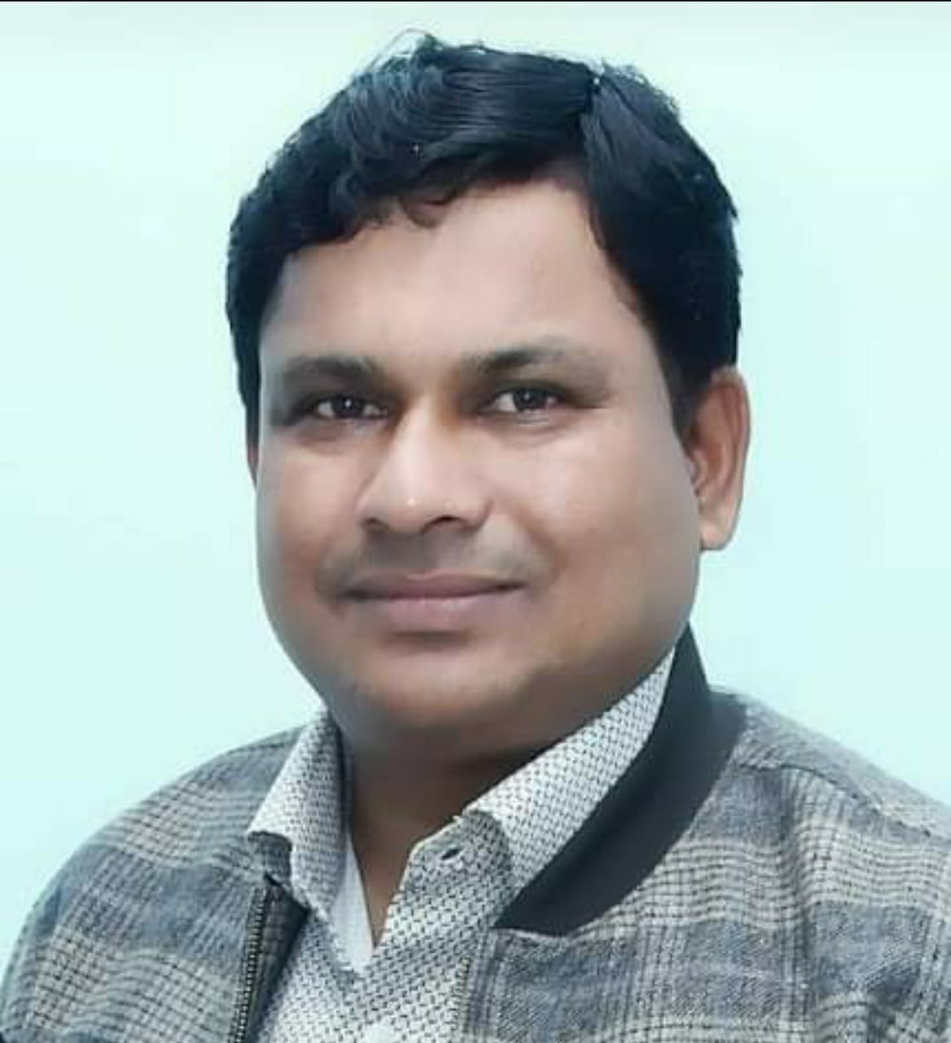

..........................

2. Qualification: MD PATHOLOGY

3. Fellowships:

4. Date of joining: 20/01/2020

5. Date of Birth: 20 Month: 12 Year 1975. Gender: MALE

6. Designation: HOD

7. Department: PATHOLOGY

8. Specialization: MD PATHOLOGY

9. Area of Interest: HEMATOLOGY & CYTOLOGY

10. OPD days: .......................NA..............................................................................................................

11. OPD Room No.: ......................N A ........................ .Timings: ....N A............

12. Super specialty clinic: ....NA....Room No / ward No. : ......NA..........

13. Super specialty clinic days.....................NA..........................Timings: ...............NA..................

14. Awards: .......................................................................................................................................

- International

- National

- State level

- District Level

15. Achievements:

a. Publications (Index/Peer reviewed): .............

Sl.  No. | Title of Article | Journal | Year/Month
1. | Blood plasma levels of Interleukin-6 and Interleukin-8 in patients of Aplastic Anaemia and their correlation with the severity of disease | Indian Journal of Medical Research | January 2022 (under publication)

b. Publications (Non indexed): ............................................................................

Sl.  No. | Title of Article | Journal | Year/Month

c. Books/Book Chapters: ...................................................................................

Sl.  No. | Author/s | Title | Publisher | Year of publication | Page No.
- . | Dr Sharvan Kumar Bhargawa | Practical Pathology for undergraduates | J P Publications | 2021

d. Invited Oral Presentations:...........................................................................................

Sl.  No. | Title | Title of conference/seminar | Year of publication | Publisher

e. Research Presentations (Oral): National................International............................

Sl.  No. | Title of the paper | Title of conference/ seminar volume | Year of publication | Publisher

f. Research Presentations (Poster): National................International...............................

Sl.  No. | Title of the paper | Title of conference/ seminar volume | Year of publication | Publisher

g.Others : …………………………………………………………………………………………………………………………….

16. Research Work : …………………………………………………………………………………………………
a. Research guidance : Awarded Submitted Ongoing
……………………. ……………………… …………………..
b. Ongoing Thesis : ……………………………………………………………………………………………….
SI No. | Title of the Project | Chief/Co-investigators | Date of Commencement | Expected date of completion
1
2
3
c.Other ongoing projects :
17. Life Memberships :
18. Grants received : ……… …………………………………………………………………………………
19. Other Corporate responsibilities
a.

20. Community Services :
21. Social Services :
22. Previous Appointments : ………
S.No. | Name of Post | From | To | Duration
2.
3.
4.
5.

23. Email: drshravan21@gmail.com
24. Website : ………………………… …………………………………………………………………………………………………………………
25. Phone/Mobile No.8755879935: (RES)… …………………………
26. Fax : ……………………………………………………………………………………………………………………………
27. Address for Communications :

